**Business Summary Report: Predictive Insights for Collections Strategy**

# 1. Summary of Predictive Insights

Using insights from your EDA (Task 1) and the structured predictive model framework (Task2). These insights can help prioritize interventions and optimize collection strategies.

• **High Credit Utilization**

* Customers using more than 80% of their available credit are significantly more likely to default.
* Indicates dependency on credit and poor cash flow.

• **History of Missed Payments**

* Past behavior is the strongest predictor of future risk.
* Even one missed payment greatly increases delinquency likelihood.

• **High Debt-to-Income (DTI) Ratio**

* A DTI above 40% suggests financial overextension.
* Customers may struggle to cover obligations if unexpected expenses arise.

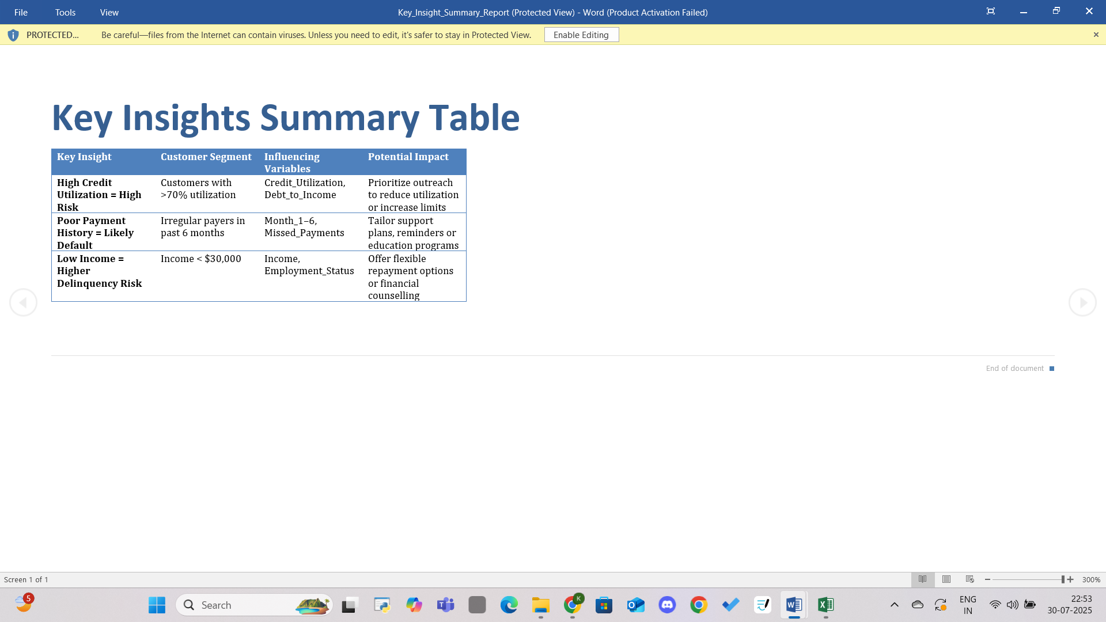

**2. Recommendation Framework**

* Restated Insight:  
  High credit utilization is a strong predictor of delinquency.
* Proposed Recommendation (SMART):
* Specific: Target customers with credit utilization over 70% for financial coaching and credit line optimization.
* Measurable: Aim to reduce average credit utilization in this group by 15% in 3 months.
* Actionable**:** Launch an outreach campaign offering personalized credit usage tips and budgeting assistance.
* Relevant**:** Reduces risk of default, aligns with Geldium’s customer-first and responsible lending approach.
* Time-bound**:** Implement and monitor outcomes quarterly, starting next month.
* Justification and Business Rationale:  
  Reducing credit utilization can significantly improve repayment behavior. It’s a proactive, low-cost intervention that strengthens customer trust while reducing portfolio risk.

# 3. Ethical and Responsible AI Considerations

• **AI Use Transparency:**  
Clearly disclose when AI tools (e.g., ChatGPT, Gemini) are used in model design or decision logic generation, ensuring transparency with both internal stakeholders and regulators.

• **Fairness and Bias Mitigation:**  
Regularly audit models for **bias across income, age, gender, or region**, especially in high-stakes predictions like credit risk.  
Use fairness-enhancing techniques (e.g., reweighting, explainable AI) to maintain equity in decision-making.

• **Human-in-the-Loop Validation:**  
Ensure all AI-generated recommendations are reviewed by **domain experts** before implementation. Combine AI efficiency with human judgment to avoid unintended consequences.

• **Privacy & Data Ethics:**  
Use only **anonymized and consent-based data** during model training and analysis. Comply with data governance regulations (e.g., GDPR, India’s DPDP Act) and secure customer trust.